Create a Tech Zone Article
This information can also be found in the External Publishing Guidelines and Procedures article on Tech Zone.
Before you create a new article in Tech Zone, see if the information you want to add already exists on Cisco.com or belongs in a document that is already published on Cisco.com. It is better to update existing content than create a new document that covers the same topic. This helps to ensure that there is not conflicting information on Cisco.com.

To find out if an article already exists, use the Topic Search site or search directly from the Tech Zone site.
Topic Search
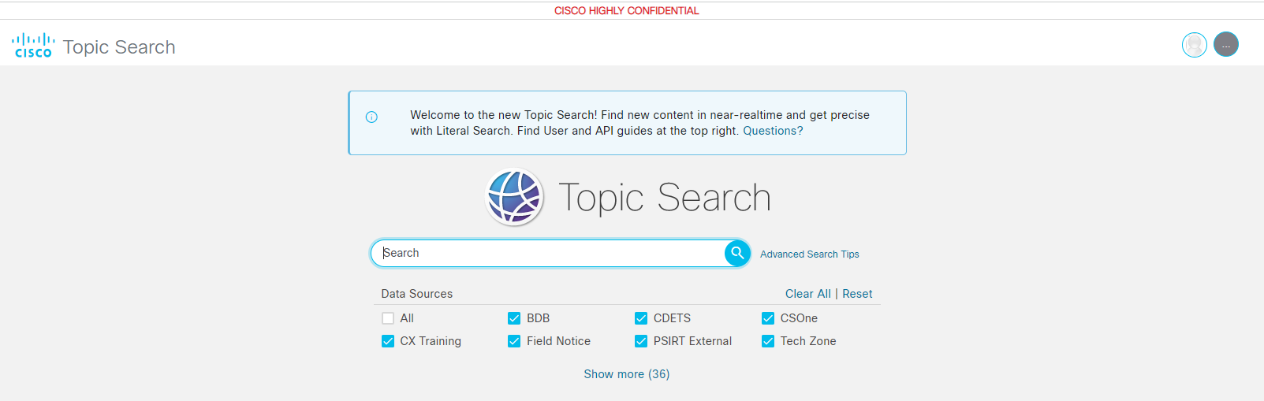
Tech Zone Search
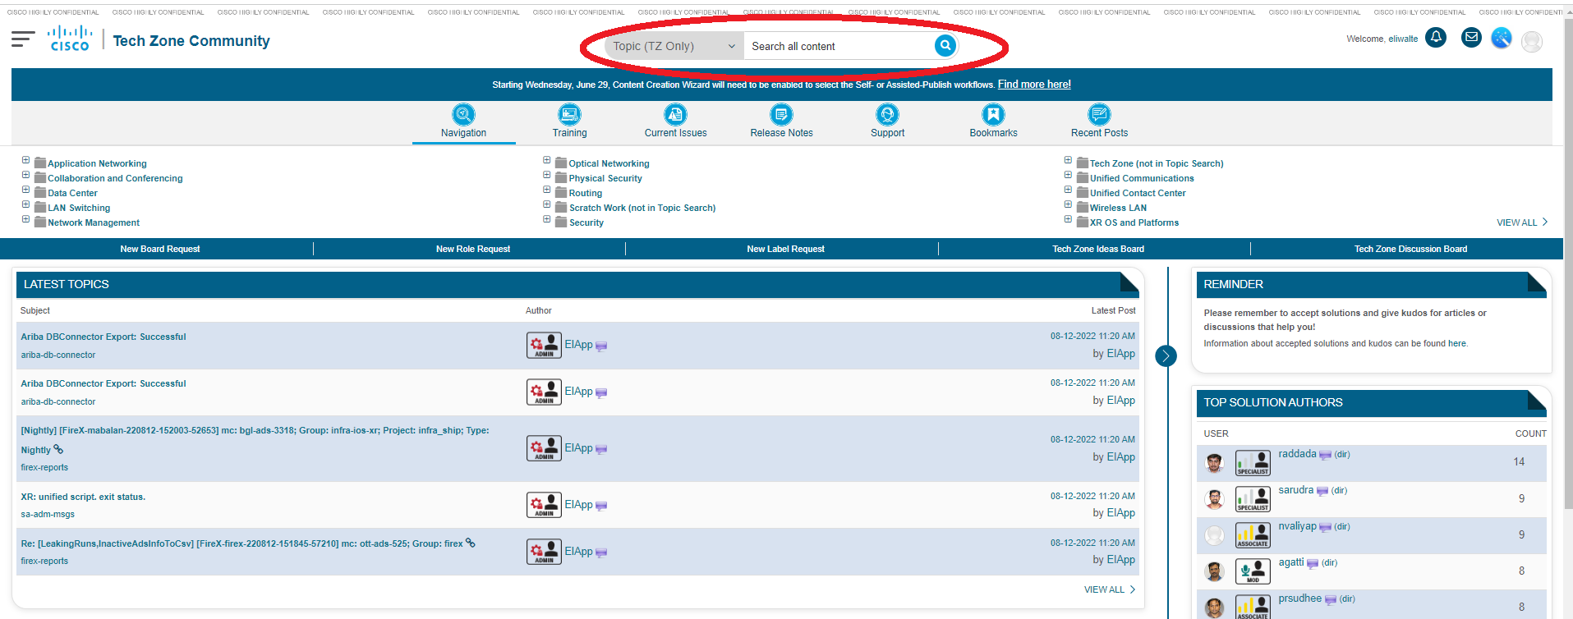

In order to provide recommended changes to an existing document, use the Feedback link on the public Cisco.com web page or open a bug on the document, and include the content that you would have added to a new article (specifics are critical; a general request takes far longer to update.)

If you are working on a DOC IC SR, there may be an article on Cisco.com but no article in Tech Zone. In that case, you would need to create a new Tech Zone in order to update/format and recertify the Cisco.com article.

Sometimes there is an article in Tech Zone related to a Recertification CSOne DOC IC SR.
It is recommended that you do a thorough search on the article title before you create or edit an article.

To create a new article in Tech Zone:
- Navigate to the knowledge base in which you want to publish the article.
- Click Create an article. The Choose Article Template page appears.

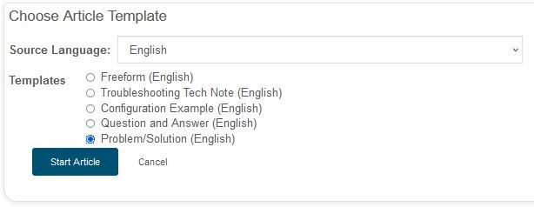
- From the Source Language drop-down list, choose the language in which the article is being written.
- From the Templates list, click a radio button to choose the template that best represents the type of article you are creating. Headings based on the selected template are added to the TZ editor.

- The template types are:
  - Freeform - This selection is not based on a template and headings are not automatically added to the document.
  - Troubleshooting TechNote - Describes general troubleshooting information.
  - Configuration Example - Describes how to configure a product or technology.
  - Question and Answer - Includes one or more question and answer pairs.
  - Problem/Solution - Includes one or more problem/solution pairs.
- Click Start Article.

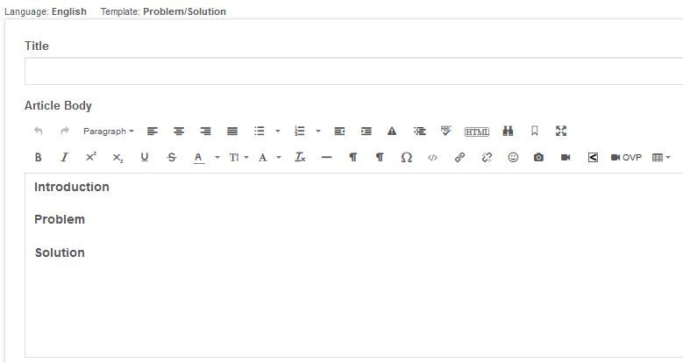

- Add a title for the article in the Title field. Follow the guidelines described in the Guidelines for Document Titles.

Note: For more information about titles, see Why must I follow specific guidelines for the title of my article?
- Add the article content in the Article Body area. Follow the content guidelines in the "Review/Update the Article Per the Content Guidelines" section.

Labels
You cannot select the Publish to Tech Zone button for a new article until you select 4 labels.

At the bottom of the page, in the Labels section, choose the label that best describes the category from each of these drop-down lists. You can also type the label in the Label Search field.

- Activity – Type of action described in the article. For example, is the information in the article about how to configure, how to troubleshoot, or meant to provide information in a Q&A format? Or select one of the other labels from the selection list.
- Content – Type of content. For example, is this article a Configuration?
- Product (Cisco) – You must select a Cisco product from this list.
- TZ Action Requests – Type of publishing for the finished article. For example, External or Internal or one of the other labels from the selection list.

- As you select a label, it is added to the Labels field.
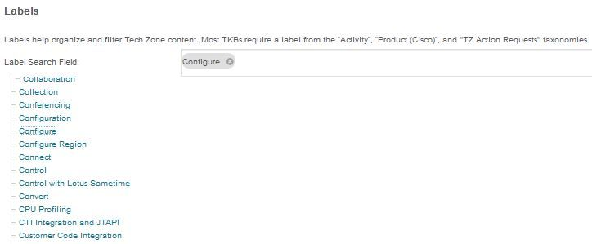

- In the Revision note field, add a description of the updates. This comment is optional and internal to Tech Zone.
- Click the Publish to TZ button located at the bottom of the page.
- The article is saved and published to Tech Zone.
- If you select the Publish to TZ button and you are unable to publish the article, it usually means there are additional or required labels you need to select.
- The interface indicate which label or labels need to be selected.
- After you select the required labels, you can publish your article to Tech Zone.

